Scenario 1: The Relic Run
Oct 1, 2026 · @Mike
A one-session teaching scenario: the party ambushes a cargo ship, boards it, seizes an ancient artifact and escapes. Each scene teaches one core system — space combat, zero-G movement, personal combat, skill checks, and a chase.

Read-aloud opening
Read this to the players word for word, then go straight to Scene 1.
Three weeks ago, in a dockside bar on Halcyon Down, a soft-spoken woman named Doctor Ilse Varro bought your drinks and slid a data wafer across the table. Her dig team had uncovered something in the ruins of Halcyon's outer moon: a palm-sized object of black, glassy stone that hums when you hold it. The locals call such things Ancients' relics. The museums call them priceless.
Before Varro could ship it, her own expedition financier, Corwen Strade, stole it. He loaded it aboard a battered free trader called the Lucky Margin, bound for a private buyer two parsecs away. Varro has paid you half your fee up front. You get the other half when the relic is back in her hands.
That was then. Now your ship is drifting powered-down in the shadow of a dead comet in the outer Tessaly system, right on the Margin's predicted path to the jump point. Your sensors are passive. Your reactor is idling. The board shows a single contact, 40,000 kilometres out and closing, running bright and careless with its transponder on.
It's the Lucky Margin. She has no idea you're here.
Who's on the bridge, and what are you doing?

GM briefing
The party wins by getting the relic aboard their own ship and jumping out before a patrol arrives. Plan on 3 to 4 hours, with about 40 minutes per scene.
What's really going on. Strade isn't working alone. His buyer has paid a corrupt customs captain to "escort" the Margin to the jump point. That patrol corvette, the Vigilant Hand, is running about 30 minutes behind. It turns up in Scene 5 and creates the time pressure for the escape.
The relic. It's a 15 cm wedge of black glass, warm to the touch, in a padded case in the cargo hold. Whenever someone touches it with bare skin, it pulses and everyone within 3 metres feels a wave of vertigo. Use this as flavor only, or as a Bane on one roll if a player handles it carelessly. What it actually does is a hook for later sessions.
The party's ship. Use the group's ship from the Spacecraft Record. The scenario assumes it has at least one turret with a pulse laser (2D damage, Long range). If it doesn't, Varro lent them a double turret with two pulse lasers for the job. Any ship with Thrust 2 or more outruns the Margin (Thrust 1).
Pre-generated characters vs. their own. Either works. Every scene has a job for a pilot, a gunner, an engineer, a sensor operator and someone who can shoot. If nobody has a given skill, roll it unskilled at DM-3. That's a teaching moment in itself.
What each scene teaches
Scene | Core system | Key rolls
1. The Ambush | Space combat: initiative, range bands, attack, damage | Pilot, Gunner, Electronics (sensors), Tactics (naval)
2. Boarding | Docking, airlocks, zero-G movement | Pilot, Electronics (computers), Athletics (dexterity), Vacc Suit
3. The Hold | Personal combat: initiative, actions, cover, damage | Gun Combat, Melee, Medic
4. The Artifact | Task checks, Effect, Boon and Bane, extended tasks | Investigate, Electronics, Mechanic, Persuade or Deception
5. The Escape | Chase, evasive action, jumping under fire | Pilot, Astrogation, Engineer (j-drive)
Teaching tip. At the start of each scene, explain the one new rule it introduces before anyone rolls. Then let them play without interruption. Save the edge cases for after the session.

Scene flow
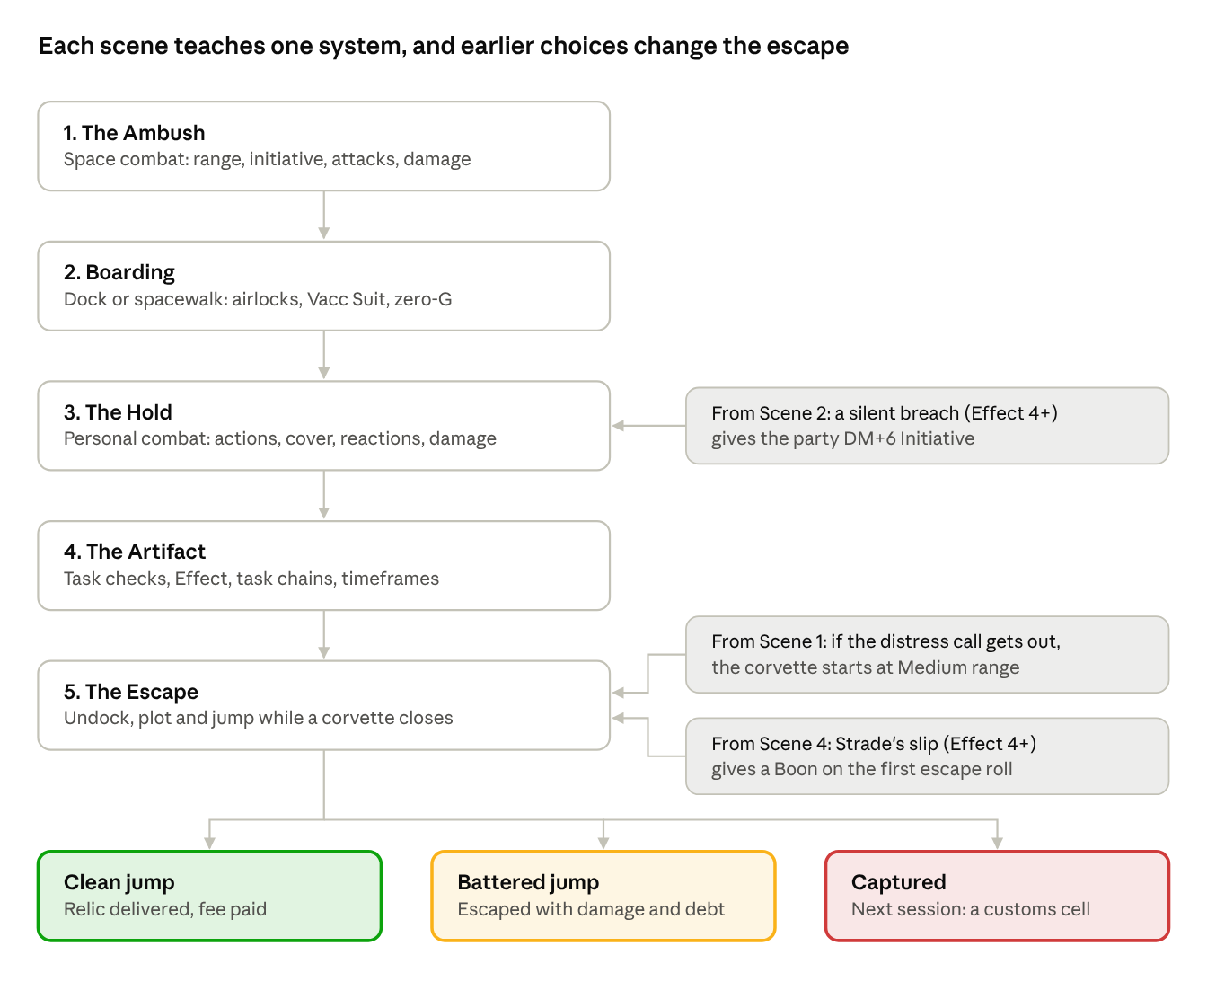
scene flow · 5 scenes, 3 carry-overs, 3 endings
The scenes run in order. The shaded notes are the three choices that carry forward and make the escape easier or harder.

Scene 1: The Ambush
The party wins this scene when the Margin can't run any more, because its drive is crippled or its crew surrenders. Blowing it up loses the relic. Teaches: space combat (Core pp.164-172).
Setup
- Assign crew duties. Every player picks one: Pilot, Captain, Gunner (one per turret), Engineer, Sensor Operator, or Marine (getting suited up for Scene 2). There's only one Pilot and one Captain.
- Let the trap close. If the party stays dark, the Margin drifts past the comet at 1,000 km, which is Short range. Say "Short range" out loud and pull up the range bands on the app's Spacecraft Combat page. If anyone powers up early, the Margin spots them at Long range (12,000 km) and you lose the surprise.
- Surprise. If the party waited, the Margin takes no actions in round 1.
- Initiative, rolled once per ship: 2D + the pilot's Pilot skill + the ship's Thrust. The Captain may first roll Tactics (naval) and add its Effect. The Margin rolls 2D+1+1.
Each 6-minute round has three steps, in Initiative order
- Manoeuvre. The Pilot spends Thrust on closing range, or holds some back for Evasive Action (each unspent point lets them dodge one attack at DM minus their Pilot skill).
- Attack. Each Gunner rolls 2D + Gunner (turret) + DEX DM, needing 8+. Add DM+1 at Short range or DM-2 at Long. Damage = weapon dice + Effect - target Armour.
- Actions. The Sensor Operator can get a Sensor Lock (Electronics (sensors) 8+ gives DM+2 to all the ship's attacks) or jam comms. The Engineer can repair or overload systems. The Captain rolls Leadership, and its Effect modifies next round's Initiative.
How the Margin fights
- Round 1 (if surprised): nothing. Describe alarms, a panicked voice on an open channel, the trader starting a slow, fat turn.
- Round 2 onward: it burns its single point of Thrust trying to run for the jump point.
- The laser turret. Tamsin Oru fires back with the pulse laser from the pilot's seat: 2D + Gunner (turret) 1, DM-2 for a pilot firing a turret, DM+1 at Short range, needing 8+. It does 2D damage minus the party's Armour. The hits are weak but real, and it's the party's first look at damage coming their way.
- The sandcaster turret. Dorran, a hired guard, mans it. Against each laser hit he makes a Gunner (turret) check at 8+. A success adds 1D + Effect to the Margin's Armour against that one shot. That's a great moment to explain Reactions.
- The distress call. In its first Actions Step, the Margin's sensor operator broadcasts for help. The party's Sensor Operator can block it with an opposed Electronics (comms) check. If the jam fails, the Vigilant Hand starts Scene 5 at Medium range instead of Long.
- Surrender. At 40 Hull or less, or when a critical hit lands on the M-Drive, Strade cuts thrust and shouts that he surrenders.
Disabling instead of destroying
- Called shot (Short range or closer): declare the M-Drive, take DM-2 to hit, and if the Effect is 6+ the critical hit goes exactly where the party aimed.
- Sustained damage: every 8 points of Hull lost (10% of 80) triggers a Severity 1 critical hit on a random location (2D). A roll of 8 is the M-Drive.
- Warn the table: a hit on Cargo (a roll of 9 on the location table) at any Severity destroys some of the cargo. Roll 1D: on a 1, the relic's case is cracked but the relic is fine. Leave everyone sweating about it until Scene 4.
Closing to board. Once the Margin has stopped, the party needs Thrust to close from Short to Adjacent: 2 Thrust from Short to Close, then 1 from Close to Adjacent. At Thrust 2 that's two rounds. Narrate it rather than rolling for it.

Scene 2: Boarding
The party wins this scene by getting a team inside the Margin. Teaches: docking, airlocks, Vacc Suit and zero-G movement (Core pp.151, 175, 81).
Option A: dock with the airlock. If Strade has surrendered, docking is a Routine (6+) Pilot check taking 1D minutes. If the Margin is still squirming, both pilots make opposed Pilot checks and the party's pilot takes DM-2. The Margin's airlock is locked from its bridge. Overriding it is a Very Difficult (12+) Electronics (computers) check, or someone on board can just open it if they're persuaded.
Option B: the spacewalk. Players love this one. The boarders jump the gap in vacc suits and cut in through the cargo hatch.
- Suiting up. Anyone without Vacc Suit skill makes an Average (8+) Vacc Suit check (DM-3 unskilled) to seal the suit properly. On a failure, they find a leak halfway across. Let them fix it with a second roll.
- Crossing the gap. This is an Average (8+) Athletics (dexterity) check. On a failure the Traveller tumbles past the hull and must be reeled back in by a tether. That costs a round but isn't fatal unless the Effect is -6 or worse.
- Cutting in. Use a Difficult (10+) Mechanic or Engineer check with a cutting torch (1D x 10 minutes). With an Effect of 4 or more, the crew inside doesn't hear it, and the boarders get the ambush DM+6 to Initiative in Scene 3.
The zero-G rule to teach now. The Margin's gravity plates failed when it took damage (narrate it). Inside the ship it's zero-G, and everyone floats. Firing a weapon without the Zero-G trait, or swinging a melee weapon, needs an Average (8+) Athletics (dexterity) check first. Fail it and you miss and start spinning. Getting back under control takes another Athletics (dexterity) 8+. Snub pistols, laser pistols and stunners have the Zero-G trait, so this is the moment players realise why spacers carry them.
Shortcut: the abstract boarding roll. If time is short, resolve the whole boarding with the Core p.175 Boarding Actions roll: both sides roll 2D plus modifiers (superior armour +1, weapons +1, skills +2, numbers +1). The defenders get DM-2 because they have no Marines. A result of 4 or more means the party is in. Use this only as a time-saver. Scene 3 is where the learning happens.

Scene 3: The Hold
The party wins this scene when the three hired guards are down or have surrendered. Teaches: personal combat (Core pp.73-78).
The space. The cargo bay is 20 m long and 10 m wide, in zero-G, lit by red emergency strips. Shipping crates are strapped in rows and give cover. The relic's case is magnetically clamped to the far wall. Strade and his two crew are locked on the bridge, and they surrender the moment anyone bangs on the door with a gun.
Read aloud as they enter:
Crates the size of ground cars hang in their straps, turning slowly. Something small and metallic tumbles past your faceplate. Probably a spent cartridge. From behind the far crates a woman's voice calls out, flat and professional: "Strade's not paying us enough to die. But he's paying us enough to try."
Running the fight, step by step
- Initiative. Each player rolls 2D + DEX DM or INT DM (their choice) against 8. The Effect (total minus 8) is their Initiative, and it stays the same every round. Roll once for all three guards using Kesh's DEX. Ambush adjustments: a silent breach gives the party DM+6 for round 1 only. A noisy breach gives the guards DM+6 instead.
- On your turn: take one Significant Action + one Minor Action, or three Minor Actions.
  - Significant: attack, first aid, or bypassing a lock.
  - Minor: move 6 m, aim (DM+1 per Minor Action spent, up to +6), draw or reload, or change stance.
- Attacking. Roll 2D + Gun Combat + DEX DM needing 8+. Apply DM-2 if the target is in cover, DM+1 at short range (within a quarter of the weapon's range), and DM-2 at long range. In zero-G, weapons without the Zero-G trait need the Athletics (dexterity) check first (see Scene 2).
- Damage. Weapon dice + Effect - armour Protection. An Effect of 6+ always does at least 1 damage. Damage comes off END first. After that, the target chooses whether it comes off STR or DEX. If STR or DEX hits 0, they're unconscious. If all three hit 0, they're dead.
- Reactions. When shot at, a Traveller may dodge (attacker takes DM minus the dodger's DEX DM or Athletics (dexterity)) or dive for cover (DM-2 to every attack on them this round, but they lose their next actions). Each reaction gives DM-1 on the Traveller's own next actions.
How the guards fight
- Kesh stays in cover and shoots with her snub pistol (Zero-G trait). She closes to melee with her cutlass if a boarder drifts within 2 m.
- Dorran arrives a round late from the sandcaster turret, carrying a shotgun, which has no Zero-G trait. Make his Athletics roll openly every time. The first time he spins helplessly across the bay, the players will understand the rule for good.
- Pell is green and nervous. He dives for cover whenever he's shot at, so his attacks are rare.
- Morale. When Kesh goes down, or two guards are wounded, the rest drop their weapons.
After the fight. A Traveller with Medic can use a Significant Action for first aid: Average (8+) Medic, restoring characteristic points equal to the Effect. This is a good time to explain that wounds in Traveller hit characteristics directly, which is part of why combat is deadly.

Scene 4: The Artifact
The party wins this scene by getting the relic out of its trapped case and onto their own ship. Teaches: task checks, Effect, task chains, timeframes, and a countdown (Core pp.59-63). This is the quiet scene. Let each player own one check.
The problem. The relic sits in a padded case magnetically clamped to the bulkhead. It's protected by two separate systems:
- The lock. A keypad releases the clamps. Strade knows the code.
- The bomb. A small charge with a dead-man circuit and a motion trigger. Strade paid someone else to fit it and doesn't really understand how it works. The code does nothing to the bomb.
The trap chain. Two branches run side by side, so different players can work at once, and both feed into the final steps. Each step's Effect becomes a DM on the step it feeds: -3 for Effect -6 or worse, -2 for -2 to -5, -1 for -1, +1 for 0, +2 for 1 to 5, and +3 for 6 or more.
Step | Who | Check | Feeds into
A1. Spot the trap | Anyone | Average (8+) Investigate (INT), or Recon | A2. On a failure they don't know it's there, and A2 takes a Bane.
A2. Read the wiring | The tech | Average (8+) Electronics (security) or Explosives (EDU) | A3. With an Effect of 4+, they also spot that one wire is a decoy.
A3. Cut the dead-man circuit | The tech | Difficult (10+) Electronics (security), 1D x 10 minutes | C1. This is the core roll.
B1. Get the code from Strade | The talker | Average (8+) Persuade (SOC), or Deception (INT) | B2. With an Effect of 4+, Strade also blurts out that "the customs boys" are coming. That gives the party a Boon on their first roll in Scene 5.
B2. Is he lying? | Anyone watching | Average (8+) INT check, or Investigate | C1. Roll this one secretly. If B1's Effect was 0 to 3, Strade gave a duress code, and entering it arms the charge unless someone catches the lie.
C1. Release the clamps | The tech | Routine (6+) Electronics (security) with the real code. Without it, Very Difficult (12+) Mechanic to force them | C2
C2. Ease it free in zero-G | Steadiest hands | Average (8+) Athletics (dexterity), or Mechanic to brace it | C3. This is the motion trigger, a callback to the zero-G rule from Scene 2. Skip it if A3 had an Effect of 6+.
C3. Carry it out | Whoever touches it | Average (8+) END check | On a failure, the relic's vertigo pulse gives that Traveller a Bane on their next roll.
Teach timeframes at A3. Before the tech rolls, ask: "Rush it, or take your time?" One step faster (1D minutes) costs DM-2. One step slower (1D hours) gives DM+2. If the players suspect a patrol is coming, this choice gets tense.
When a step fails
- Effect -1: a marginal failure. Offer success at a cost, such as a spark, a scorched hand, or 1 damage.
- Effect -2 to -5: the charge arms. Switch to 6-second rounds. The party has 1D rounds to finish the remaining steps or get clear.
- Effect -6 or worse, or the timer runs out: it detonates for 3D damage to everyone within 2 metres, and the bulkhead breaches. The relic survives, which hints it's more than it looks. The Margin loses cabin pressure, so anyone not sealed in a vacc suit now has a new problem. (The 3D is a house number, not from the book. Lower it if you want the bomb to scare rather than kill.)
Optional campaign hook. A Routine (6+) Electronics (computers) check on the Margin's bridge pulls its nav logs. They name the buyer, the Aldane Collection, and show a jump plot ending at a system no merchant ship should want to visit. Use it to set up the next session.

Scene 5: The Escape
The party wins when their ship jumps out with the relic aboard. The Vigilant Hand is far too strong to beat in a fight, and the scene teaches them to recognise that. Teaches: fleeing, evasive action, and jumping under fire (Core pp.157, 165-172).
Read aloud the moment the relic is aboard:
Your board chimes. A new contact burns in from sunward, and its transponder resolves into the crest of the Tessaly System Customs Service. Patrol corvette Vigilant Hand. A clipped voice fills the bridge: "Unidentified vessel. You are interfering with a vessel under customs escort. Cut your drive and prepare to be boarded."
Starting position. The corvette starts at Long range (12,000 km), or Medium if the Margin's distress call got out. Re-roll Initiative for both ships. The Vigilant Hand rolls 2D+2+4, because it has Pilot 2 and Thrust 4.
The party's to-do list. They need three things, and they can do them in parallel across crew stations:
- Undock if they're still attached to the Margin: a Routine (6+) Pilot check, taking one round.
- Plot the jump: normally an Easy (4+) Astrogation check, but raised to Routine (6+) in combat, with DM-1 per parsec. If anyone said earlier that they pre-plotted their escape jump, skip this step and reward the foresight.
- Fire the jump drive: normally an Easy (4+) Engineer (j-drive) check, raised to Routine (6+) in combat, with the Astrogation Effect applied as a task chain DM. In combat it takes 1D minutes, so it happens within this round.
How the corvette fights. Each round it fires its two triple pulse-laser turrets (Gunner 2). One attack roll per turret, at DM-2 at Long range, does 2D+4 damage per hit. Its first round is a warning shot across the bow. Make that roll openly so the players can see the numbers. If the party's ship takes a hit, use the damage and critical hit rules from Scene 1. Now they're on the receiving end.
Party options to teach
- Evasive Action. Every point of Thrust the pilot doesn't spend is a dodge, and each dodge gives an incoming attack DM equal to minus the pilot's Pilot skill.
- Run. If both ships thrust in opposite directions, subtract the lower Thrust from the higher. The corvette (Thrust 4) will gain on almost anyone, so running only buys time for the jump.
- Electronic Warfare. The Sensor Operator can break the corvette's sensor lock with opposed Electronics (sensors) checks.
- Talk. The corvette's captain is bought, not loyal. A Difficult (10+) Persuade or Deception check, perhaps threatening to broadcast the Margin's logs from Scene 4, makes him hold fire for one round. On an Effect of 6+, he "loses them on sensors" entirely.
- Hand over Strade. Leaving the Margin and its crew behind gives the corvette a reason to stop and recover them. That buys one free round.
Endings
- Clean jump. The party arrives at Halcyon Down, Varro pays the second half of the fee, and she asks them to stay on for something bigger.
- Battered jump. They escape with critical hits. Repairs and debt are a natural lead-in to the next session.
- Captured. If their Hull falls below half and they have no jump, the corvette boards them. Next session starts in a customs cell, with the relic in an evidence locker.

Cast and stat blocks
Characteristics are listed in Traveller order: STR DEX END INT EDU SOC. Weapon and armour stats are from the Core Rulebook's equipment chapter.
Ships
Ship | Tons | Thrust | Armour | Hull | Weapons | Crew skills
Lucky Margin (free trader, Type A) | 200 | 1 | 2 | 80 | Single turret: pulse laser (2D, Long); single turret: sandcaster | Pilot 1, Gunner (turret) 1, Electronics (sensors) 1
Vigilant Hand (patrol corvette, Type T) | 400 | 4 | 4 | 160 | 2 triple turrets of pulse lasers (2D+4 each, Long); 2 triple missile turrets, held back so the relic isn't destroyed | Pilot 2, Gunner (turret) 2, Tactics (naval) 1; 8 marines aboard
People aboard the Margin
Name | Role | STR DEX END INT EDU SOC | Skills | Gear
Corwen Strade | Thief and financier; cowardly, talks fast | 6 7 6 9 9 8 | Broker 2, Deception 1, Persuade 1, Admin 1 | Body pistol (not drawn)
Tamsin Oru | Margin's pilot; just wants to live | 6 8 7 8 7 6 | Pilot 1, Electronics (sensors) 1, Gunner (turret) 1 | none
Brask | Engineer; hates Strade | 9 6 8 7 8 5 | Engineer (m-drive) 1, Mechanic 1 | Wrench (club, 2D)
Mara Kesh | Lead guard; ex-marine, professional | 8 9 8 7 6 5 | Gun Combat (slug) 2, Melee (blade) 1, Athletics (dexterity) 1, Vacc Suit 1, Tactics (military) 1 | Snub pistol (3D-3, Zero-G), cutlass (3D), cloth armour (+5)
Dorran | Guard; big, slow, brave | 9 7 9 6 5 5 | Gun Combat (slug) 1, Melee (unarmed) 1, Gunner (turret) 0 | Shotgun (4D, 50 m, no Zero-G trait), mesh (+2)
Pell | Guard; nineteen, terrified | 6 7 6 7 7 6 | Gun Combat (energy) 0 | Stunner (2D, Stun, Zero-G)
Notes for running them
- DEX DMs: 9 gives Kesh +1. Everyone else here is +0.
- Pell's stunner is a chance to teach the Stun trait: its damage only reduces END, and a target knocked to END 0 is unconscious rather than hurt.
- Brask can be turned. An Average (8+) Persuade check gets him to unlock the bridge or the airlock for the party.
- Pre-gens or their own characters? If the players are new, Kesh is a good model for a sample Traveller. Walk them through her stat line before Scene 3 so the numbers on their own sheets make sense.

